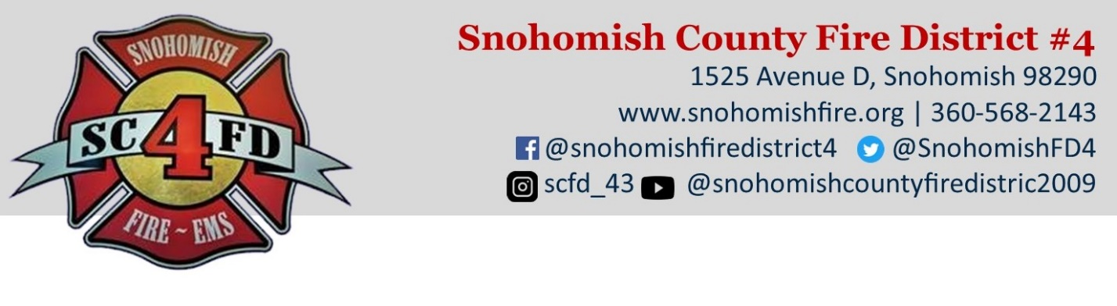
FOR IMMEDIATE RELEASE

Date: March 16, 2023
Contact: Chief Don Waller | Office (360) 568-2141 | DonW@snohomishfire.org

Board of Fire Commissioners Passes Fire Levy Lid Lift Resolution
Proposal will appear on the August 1, 2023, primary election ballot

Snohomish, Wash. – The Board of Fire Commissioners for Snohomish County Fire District 4 passed a resolution to place a fire levy lid lift on the August 1, 2023, primary election ballot. The lid lift would fund eight firefighters to respond to higher call volumes and overlapping calls. It would also allow the fire district to pay cash to build a fire station on Pine Avenue instead of borrowing money, which costs taxpayers more in interest payments.

“Call volumes are steadily increasing and now we have the issue with overlapping calls, which are happening 28 percent of the time,” Fire Chief Don Waller said. “More firefighters and adequate facilities are necessary to respond to the growing demand for emergency services.”

The additional personnel will allow for a fire engine and medic unit to be put into service at the same time. Currently, the fire district can staff just one or the other. This will reduce response times and increase capacity districtwide. The additional personnel will also reduce the amount of overtime the fire district pays to firefighters who must work extra shifts to respond to higher call volumes.

The lid lift would also build a fire station on Pine Avenue and replace another one as funding allows. This would allow for faster response times and provide modern decontamination facilities to improve firefighter health and safety. If the lid lift is approved, the fire district can pay for these projects outright instead of financing them, which costs taxpayers more in interest payments.

The fire district is asking voters to return the fire levy from $1.15 to $1.50 per $1,000 of assessed property value. The lid lift would cost an additional $15 per month for the owner of a $500,000 home.

More information about the fire levy lid lift can be found at www.snohomishfire.org. Fire Chief Waller also welcomes your questions at 360-568-2141 or donw@snohomishfire.org.

###

Snohomish County Fire District 4 provides fire and life safety services to 32,000 people over 62 square miles. The fire district relies on full-time and part-time emergency personnel and volunteer chaplains who respond to an average of 4,500 calls per year, of which 60 percent are for Emergency Medical Service (EMS). The fire district’s firefighters are highly trained to provide quality emergency services including fire suppression and prevention, EMS, water rescue, hazardous material spills, auto extrication and life safety programs.

