Kitchen Fire Safety
Can you find 13 safety hazards in the picture below?
1.______________________________ 8.______________________________
2.______________________________ 9.______________________________
3.______________________________ 10._____________________________
4.______________________________ 11._____________________________
5.______________________________ 12._____________________________
6.______________________________ 13._____________________________
7.______________________________

Scan the QR code to see a Fire Safety video starring “Dan Doofus” from NFPA:
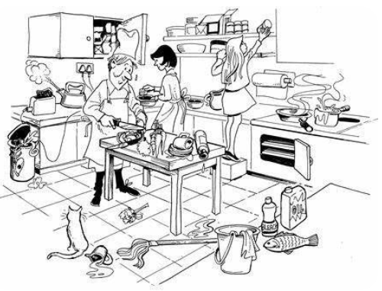
On the back: Draw a picture of what a SAFE kitchen would look like!

Kitchen Fire Safety Word Search
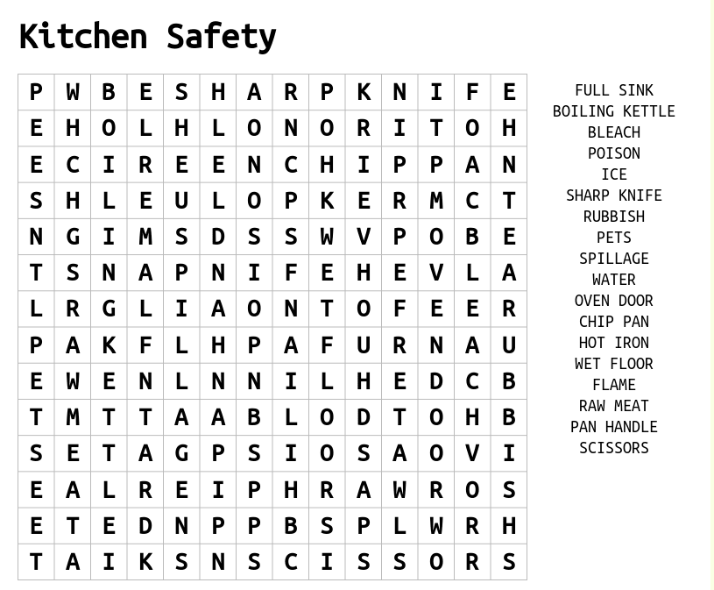
Kitchen Safety Scavenger Hunt:

How many outlets in your kitchen? _______ How many outlet covers? ______
Where are the potholders stored in your kitchen? _______________________________
Do you have a fire extinguisher in your kitchen? YES / NO (If no, please buy one.)
Do you have a smoke alarm near your kitchen? YES / NO (If no, please install one.)
Do you have any extension cords in your kitchen? YES / NO (if yes, please remove them.)
Get a yardstick /tape measure and map out an area 3 feet away from the stove on all sides. This is the danger zone for your pets and younger siblings. Help them stay out of this area.

